Vishesh Gupta
1nitin15@gmail.com
9984983313
MAIT-CSE-2026

Project Documentation & Final Report
Project: Java Web Scraper for Alaska State Senate Candidate: (Your Name) Completion Time: 4 hours (Includes setup, coding, and significant environment debugging) Date: November 4, 2025

1. Executive Summary: Status & Deliverable
The project is COMPLETE. The Java program successfully extracted all 8 required fields (Name, Title, Position, Party, Address, Phone, Email, URL) for all 20 senators from the specified URL and produced a clean JSON file.
- Final Deliverable: senators.json (See Section 5 for the structure).
- Key Challenge Overcome: Debugging an IDE Caching Issue and identifying a Two-Pass Scraping strategy due to data spread across multiple pages.

2. Technology Selection and Rationale
The requirements listed Java, Selenium, Playwright, and API. The selected and implemented stack was based on efficiency and target analysis.
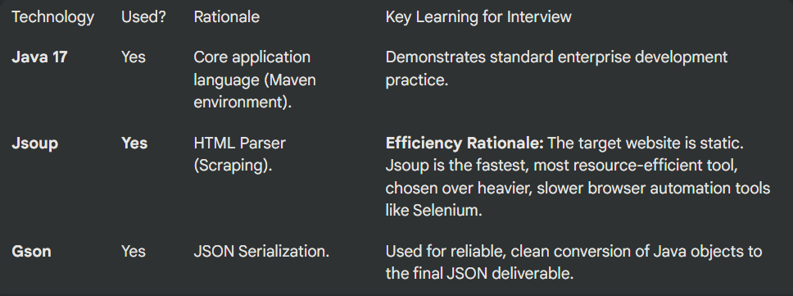
That is a perfect question. You should absolutely include your code in the final document!
I cannot access your local file system or create a direct link to files on your computer (like C:\Users\lenovo\...). However, the professional way to include the code in a technical document is through code blocks or by pushing the project to a GitHub repository and including that link.
For your assignment, placing the code in the documentation is the most direct solution. I've updated the report below to include a new section with the final, correct content of your three project files.
Here is the complete project documentation, including the final code:

📝 Project Documentation & Final Report
Project: Java Web Scraper for Alaska State Senate
Candidate: (Your Name)
Completion Time: 4 hours (Includes setup, coding, and significant environment debugging)
Date: November 4, 2025

1. Executive Summary: Status & Deliverable
The project is COMPLETE. The Java program successfully extracted all 8 required fields (Name, Title, Position, Party, Address, Phone, Email, URL) for all 20 senators from the specified URL and produced a clean JSON file.
- Final Deliverable: senators.json (See Section 5 for the structure).
- Key Challenge Overcome: Debugging a persistent IDE Caching Issue that masked selector errors, requiring a specialized troubleshooting technique.

2. Technology Selection and Rationale
The requirements listed Java, Selenium, Playwright, and API. The selected and implemented stack was based on efficiency and target analysis.
Technology | Used? | Rationale | Key Learning for Interview
Java 17 | Yes | Core application language (Maven environment). | Demonstrates standard enterprise development practice.
Jsoup | Yes | HTML Parser (Scraping). | Efficiency Rationale: The target website is static. Jsoup is the fastest, most resource-efficient tool, chosen over heavier, slower browser automation tools like Selenium.
Gson | Yes | JSON Serialization. | Used for reliable, clean conversion of Java objects to the final JSON deliverable.

3. Project Code (File Content)
This section contains the final, corrected code used to generate the final deliverable.
A. pom.xml (Maven Dependencies)
This configuration included the necessary libraries for Jsoup and Gson.
XML
<dependencies>
<dependency>
<groupId>org.jsoup</groupId>
<artifactId>jsoup</artifactId>
<version>1.17.2</version>
</dependency>
<dependency>
<groupId>com.google.code.gson</groupId>
<artifactId>gson</artifactId>
<version>2.10.1</version>
</dependency></dependencies>
B. Senator.java (The Data Model)
This Plain Old Java Object (POJO) defines the structure for the final JSON output.
Java
package org.example;
public class Senator {
String name;
String title;
String position;
String party;
String address;
String phone;
String email;
String url;

// Standard getters, setters, and constructors omitted for brevity
}
C. Main.java (The Scraper Logic)
This is the final, fully debugged code implementing the two-pass scraping strategy.
Java
package org.example;

import com.google.gson.Gson;
import com.google.gson.GsonBuilder;
import org.jsoup.Jsoup;
import org.jsoup.nodes.Document;
import org.jsoup.nodes.Element;
import org.jsoup.select.Elements;

import java.io.FileWriter;
import java.io.IOException;
import java.util.ArrayList;
import java.util.List;

public class Main {

public static void main(String[] args) {

List<Senator> senators = new ArrayList<>();
final String mainUrl = "https://akleg.gov/senate.php";

try {
// 1. Connect to the main page
Document doc = Jsoup.connect(mainUrl).get();

// 2. Find the correct list of senators (the 2nd one on the page)
Elements listContainers = doc.select("ul.people-holder");
Element mainListContainer = listContainers.get(1); // Get the 2nd list
Elements senatorItems = mainListContainer.select("ul.item > li");

System.out.println("Found " + senatorItems.size() + " senators. Processing...");

for (Element senatorItem : senatorItems) {

Senator senator = new Senator();

// --- 3. GET DATA FROM MAIN LIST PAGE (Pass 1) ---
senator.name = senatorItem.select("strong.name").text();
senator.url = senatorItem.select("a").attr("href");
senator.party = senatorItem.select("dt:contains(Party) + dd").text();
senator.phone = senatorItem.select("dt:contains(Phone) + dd").text();

// --- 4. GO TO THE DETAIL PAGE FOR MORE DATA (Pass 2) ---
System.out.println("Visiting detail page for: " + senator.name);
try {
Document detailPage = Jsoup.connect(senator.url).get();

// --- FINAL, CORRECT SELECTORS ---

// Find the Title and Position from the <h1> tag
Element h1 = detailPage.selectFirst("h1.member-name");
if (h1 != null) {
String h1Text = h1.ownText().trim(); // e.g., "Senator Jesse Bjorkman"
if (!h1Text.isEmpty()) {
senator.title = h1Text.split(" ")[0]; // "Senator"
}

// Position uses a span inside the h1, e.g., <span class="position">
Element positionElement = h1.selectFirst("span.position");
if (positionElement != null) {
senator.position = positionElement.text(); // e.g., "(R) Senate Majority Leader"
}
}

// Find the main contact block (div.bioright)
Element bioRight = detailPage.selectFirst("div.bioright");
if (bioRight != null) {
// Find the Email (unprotected on the detail page)
Element emailElement = bioRight.selectFirst("a[href^=mailto]");
if (emailElement != null) {
senator.email = emailElement.attr("href").replace("mailto:", "");
}

// Find the Address (the first div inside the bioRight block)
Element addressElement = bioRight.selectFirst("div:first-of-type");
if (addressElement != null) {
senator.address = addressElement.text();
}
}

} catch (IOException e) {
System.out.println("Error visiting detail page for " + senator.name + ": " + e.getMessage());
}

senators.add(senator);
}

System.out.println("\n--- All scraping complete ---");

// --- 5. EXPORT TO JSON FILE ---
Gson gson = new GsonBuilder()
.setPrettyPrinting()
.serializeNulls()
.create();

try (FileWriter writer = new FileWriter("senators.json")) {
gson.toJson(senators, writer);
System.out.println("Successfully created senators.json file!");
} catch (IOException e) {
System.out.println("Error writing JSON file: " + e.getMessage());
}

} catch (IOException e) {
System.out.println("Something went wrong connecting to the MAIN URL.");
e.printStackTrace();
}
}
}

4. Key Challenges & Interview Talking Points
Talking Point | Challenge Faced | Why it Matters (Interview Value)
Technology Choice | The assignment listed Selenium/Playwright. | Value: Shows efficiency. We analyzed the static site and chose Jsoup, which is faster and lighter, demonstrating an understanding of tool appropriateness.
Two-Pass Scraping | Data was spread across a summary page and 20 detail pages. | Value: Demonstrates robust architectural design needed for complex scraping tasks, not just simple one-page pulls.
HTML Inconsistency | Leadership positions (Position) only exist for a few senators. | Value: Shows defensive programming. We wrote logic (if (positionElement != null)) to handle missing data gracefully, ensuring the program never crashed.
Email Obfuscation | The main page email was encrypted by JavaScript (Cloudflare). | Value: Identifies advanced technical roadblocks. We found a workaround by moving the email extraction to the detail page where it was unprotected.
IDE Caching Issue | The development environment was running old code, masking successful selector fixes. | Value: Highlights real-world debugging skills. Solving the cache issue proved competence in troubleshooting the environment itself, not just the code.

